Web Lab 4 Activities

Name: Nisha
Section:F
CMS id: 023-24-0178

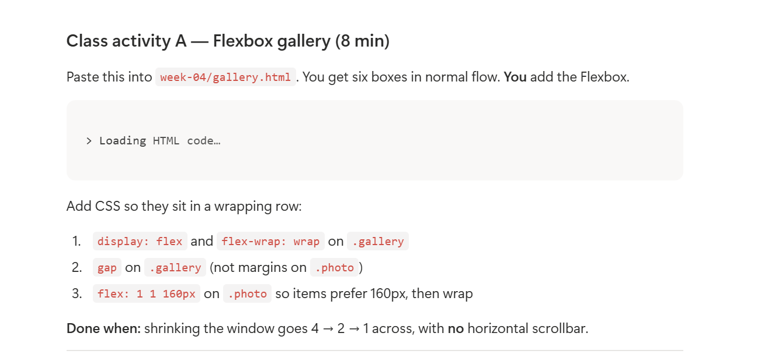
<!DOCTYPE html>
<html lang="en">
<head>
<meta charset="UTF-8"/>
<meta name="viewport" content="width=device-width, initial-scale=1"/>
<title>Flexbox gallery</title>

<style>
body {
font-family: system-ui, sans-serif;
padding: 1rem;
}

.gallery {
display: flex;
flex-wrap: wrap;
gap: 10px;
}

.photo {
background: #ddd;
padding: 2rem 1rem;
text-align: center;
flex: 1 1 160px;
}
</style>
</head>

<body>
<h1>Flexbox gallery</h1>

<section class="gallery">
<div class="photo">1</div>
<div class="photo">2</div>
<div class="photo">3</div>
<div class="photo">4</div>
<div class="photo">5</div>
<div class="photo">6</div>
</section>
</body>
</html>
Output:
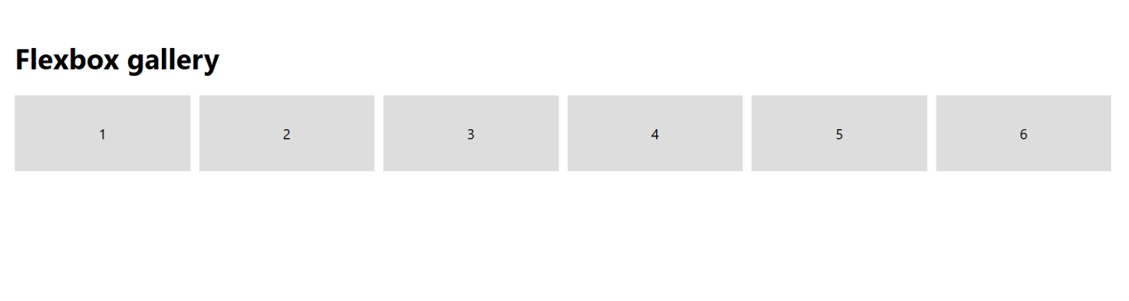

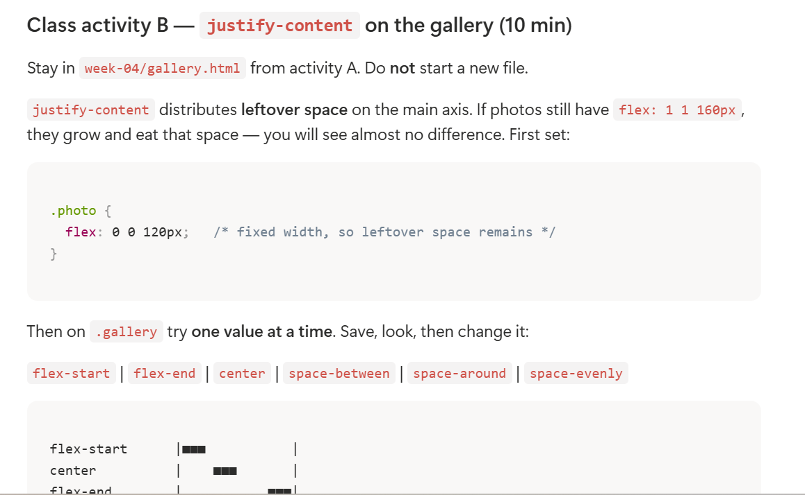
<!DOCTYPE html>
<html lang="en">
<head>
<meta charset="UTF-8"/>
<meta name="viewport" content="width=device-width, initial-scale=1"/>
<title>Flexbox gallery</title>

<style>
body {
font-family: system-ui, sans-serif;
padding: 1rem;
}

.gallery {
display: flex;
flex-wrap: wrap;
gap: 10px;
justify-content: flex-start;
}

.photo {
background: #ddd;
padding: 2rem 1rem;
text-align: center;
flex: 0 0 120px;
}
</style>
</head>

<body>
<h1>Flexbox gallery</h1>

<section class="gallery">
<div class="photo">1</div>
<div class="photo">2</div>
<div class="photo">3</div>
<div class="photo">4</div>
<div class="photo">5</div>
<div class="photo">6</div>
</section>
</body>
</html>

Output:
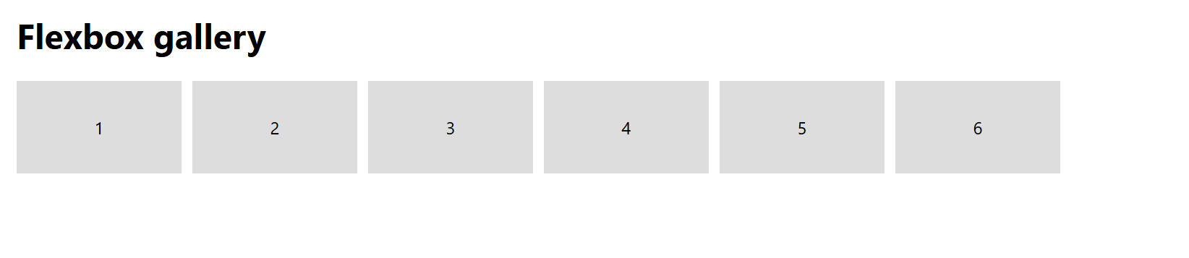


<!DOCTYPE html>
<html lang="en">
<head>
<meta charset="UTF-8"/>
<meta name="viewport" content="width=device-width, initial-scale=1"/>
<title>Grid gallery</title>

<style>
body {
font-family: system-ui, sans-serif;
padding: 1rem;
}

.gallery {
display: grid;
grid-template-columns: repeat(auto-fit, minmax(250px, 1fr));
gap: 1rem;
}

.photo {
background: #ddd;
padding: 2rem 1rem;
text-align: center;
}
</style>
</head>

<body>
<h1>Grid gallery</h1>

<section class="gallery">
<div class="photo">1</div>
<div class="photo">2</div>
<div class="photo">3</div>
<div class="photo">4</div>
<div class="photo">5</div>
<div class="photo">6</div>
</section>
</body>
</html>
Output:
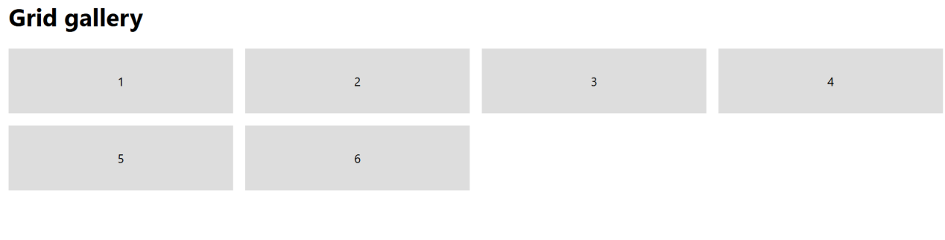

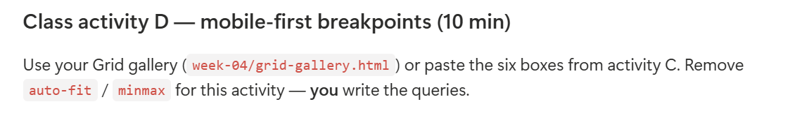
<!DOCTYPE html>
<html lang="en">
<head>
<meta charset="UTF-8"/>
<meta name="viewport" content="width=device-width, initial-scale=1"/>
<title>Grid gallery</title>

<style>
body {
font-family: system-ui, sans-serif;
padding: 1rem;
}

.gallery {
display: grid;
grid-template-columns: 1fr;
gap: 1rem;
}

.photo {
background: #ddd;
padding: 2rem 1rem;
text-align: center;
}

@media (min-width: 640px) {
.gallery {
grid-template-columns: repeat(2, 1fr);
}
}

@media (min-width: 768px) {
.gallery {
grid-template-columns: repeat(3, 1fr);
}
}

@media (min-width: 1024px) {
.gallery {
grid-template-columns: repeat(4, 1fr);
}
}

@media (min-width: 1280px) {
.gallery {
grid-template-columns: repeat(4, 1fr);
gap: 2rem;
}
}
</style>
</head>

<body>
<h1>Grid gallery</h1>

<section class="gallery">
<div class="photo">1</div>
<div class="photo">2</div>
<div class="photo">3</div>
<div class="photo">4</div>
<div class="photo">5</div>
<div class="photo">6</div>
</section>
</body>
</html>

Output:
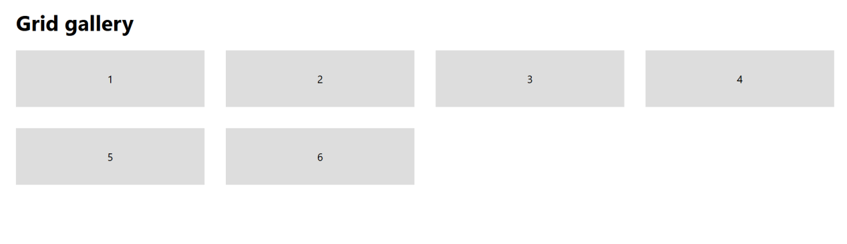

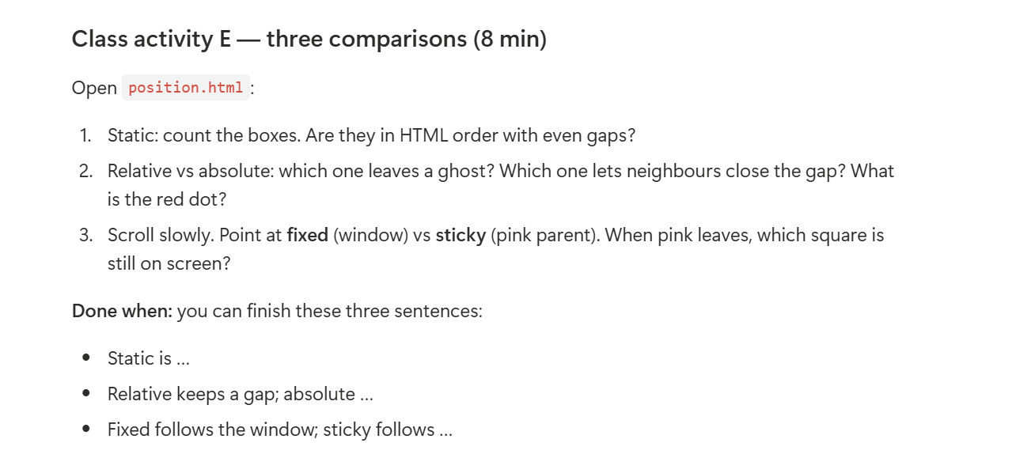
<!DOCTYPE html>
<html lang="en">
<head>
<meta charset="UTF-8"/>
<meta name="viewport" content="width=device-width, initial-scale=1"/>
<title>CSS position — boxes</title>

<style>
* {
box-sizing: border-box;
}

body {
margin: 0;
font-family: system-ui, sans-serif;
line-height: 1.45;
color: #1a237e;
}

h1 {
font-size: 1.4rem;
margin: 1.5rem 1.5rem 0.25rem;
}

h2 {
font-size: 1.05rem;
margin: 1.75rem 1.5rem 0.35rem;
}

.lead {
margin: 0 1.5rem 1rem;
}

.sq {
width: 72px;
height: 72px;
border-radius: 6px;
}

.purple {
background: #7c4dff;
}

.navy {
background: #1a237e;
}

.mint {
background: #69f0ae;
}

.pink {
background: #f8bbd0;
}

.window {
margin: 0 1.5rem 1rem;
padding: 10px;
background: #1a237e;
border-radius: 10px;
}

.window-bar {
height: 10px;
margin-bottom: 8px;
background: #90caf9;
opacity: 0.35;
border-radius: 4px;
}

.window-body {
background: #3949ab;
min-height: 160px;
border-radius: 6px;
padding: 12px;
}

.row {
display: flex;
gap: 10px;
align-items: flex-start;
}

.slot {
position: relative;
width: 72px;
height: 72px;
flex: 0 0 72px;
}

.ghost {
position: absolute;
inset: 0;
border: 2px dotted #fff;
border-radius: 6px;
}

.nudge {
position: relative;
top: 22px;
left: 22px;
}

.abs-frame {
position: relative;
min-height: 170px;
}

.origin {
position: absolute;
top: 8px;
left: 8px;
width: 12px;
height: 12px;
background: #ff1744;
border-radius: 50%;
z-index: 2;
}

.abs-child {
position: absolute;
top: 28px;
left: 28px;
}

.fixed-sq {
position: fixed;
right: 1rem;
bottom: 1rem;
z-index: 40;
box-shadow: 0 4px 16px rgb(0 0 0 / 0.35);
}

.sticky-parent {
margin: 0 1.5rem 2rem;
min-height: 160vh;
background: #f8bbd0;
border-radius: 10px;
padding: 8px;
}

.sticky-sq {
position: sticky;
top: 8px;
}
</style>
</head>

<body>

<h1>Five positions, three ideas</h1>

<p class="lead">
Coloured squares. Then scroll to the pink panel.
</p>

<h2>1. Static — simple flow</h2>

<p class="lead">
HTML order. Nothing is offset.
</p>

<div class="window">
<div class="window-bar"></div>

<div class="window-body">
<div class="row">
<div class="sq purple"></div>
<div class="sq navy"></div>
<div class="sq mint"></div>
</div>
</div>
</div>

<h2>2. Relative vs Absolute</h2>

<p class="lead">
<strong>Relative</strong> — middle box moves. Dotted ghost = the seat it still owns. Neighbours stay put.
</p>

<div class="window">
<div class="window-bar"></div>

<div class="window-body">
<div class="row">
<div class="sq purple"></div>

<div class="slot">
<div class="ghost"></div>
<div class="sq navy nudge"></div>
</div>

<div class="sq mint"></div>
</div>
</div>
</div>

<p class="lead">
<strong>Absolute</strong> — mint box leaves the row. Neighbours close the gap. It is measured from the
<strong>red dot</strong>.
</p>

<div class="window">
<div class="window-bar"></div>

<div class="window-body abs-frame">
<span class="origin"></span>

<div class="row">
<div class="sq purple"></div>
<div class="sq pink"></div>
</div>

<div class="sq mint abs-child"></div>
</div>
</div>

<h2>3. Fixed vs Sticky — scroll now</h2>

<p class="lead">
The mint square at the bottom-right is <strong>fixed</strong>. It stays on the window the whole time.
</p>

<div class="sq mint fixed-sq"></div>

<p class="lead">
The mint square in the pink panel is <strong>sticky</strong>. It sticks to the top while pink is on screen, then scrolls away with pink.
</p>

<div class="sticky-parent">
<div class="sq mint sticky-sq"></div>

<p style="padding: 1rem;">
Keep scrolling inside this pink parent…
</p>

<p style="padding: 1rem;">
Sticky is still here, stuck to the top.
</p>

<p style="padding: 1rem;">
When this pink box leaves the window, sticky leaves too. Fixed would not.
</p>
</div>

</body>
</html>

Output:
